Men's Fur Jackets: 10 Best-Selling Bomber Jackets for 2024

Introduction
As the fashion landscape evolves, men's fur jackets, especially bomber jackets, continue to make a statement. With 2024 upon us, it's time to update your wardrobe with the latest trends in outerwear. From sleek designs to cozy insulation, these bomber jackets are stylish and functional, perfect for adding a touch of sophistication to your look.
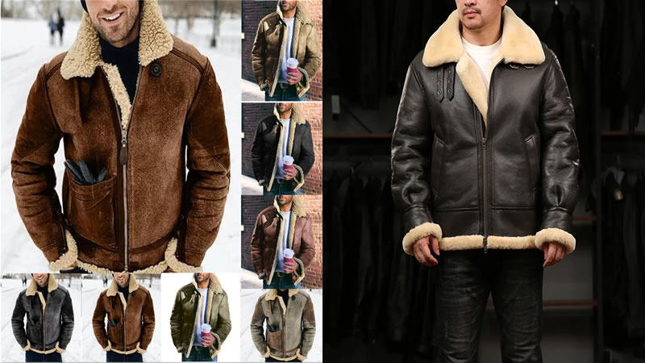

1. Classic Leather Bomber with Fur Collar
Combining timeless elegance with modern flair, the classic leather bomber with a fur collar is a must-have for any fashion-forward man. Crafted from high-quality leather and featuring a luxurious fur collar, this jacket exudes sophistication and style.

2. Quilted Bomber with Faux Fur Lining
Stay warm and cozy in a quilted bomber jacket with faux fur lining. Perfect for chilly days, this jacket offers both style and functionality, with its quilted design providing extra insulation and the faux fur lining adding a touch of luxury.

3. Shearling Bomber Jacket
Embrace rustic charm with a shearling bomber jacket that exudes timeless appeal. Crafted from soft shearling fur and featuring a classic bomber silhouette, this jacket is perfect for adding a rugged yet stylish touch to your look.

4. Bold Print Bomber with Fur Trim
Make a statement with a bold print bomber jacket featuring fur trim. Whether you opt for a vibrant pattern or a subtle print, this jacket will turn heads wherever you go, adding a touch of personality to your ensemble.

5. Hooded Bomber with Fur Lining
Stay warm and dry in a hooded bomber jacket with a fur lining. Perfect for braving the elements, this jacket offers style and functionality, with its hood providing extra protection from the wind and rain.
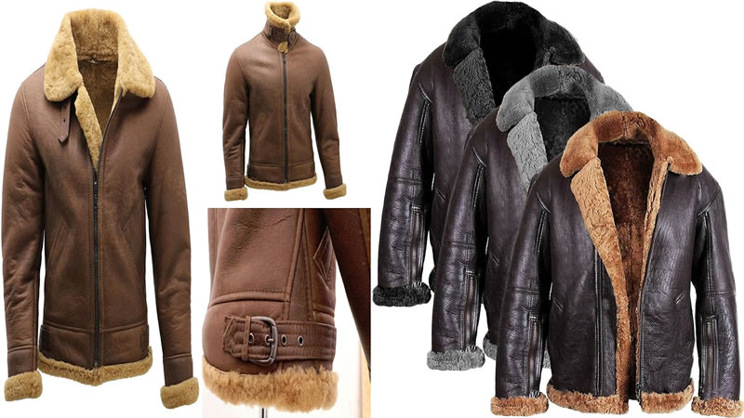

6. Bomber Jacket with Fur-Trimmed Hood
Add a touch of luxury to your look with a bomber jacket featuring a fur-trimmed hood. Whether you opt for real fur or men's fur jackets, this jacket will elevate your ensemble, adding a touch of sophistication to your winter wardrobe.

7. Puffer Bomber with Removable Fur Collar
Stay warm and stylish in a puffer bomber jacket with a removable fur collar. Perfect for transitioning from day to night, this jacket offers versatility and comfort, with its puffer design providing extra insulation and the removable fur collar adding a touch of luxury.

8. Wool Bomber Jacket with Fur Accents
Add a touch of elegance to your look with a wool bomber jacket featuring fur accents. Whether you opt for a classic black or a bold color, this jacket will elevate your ensemble, adding a touch of sophistication to your winter wardrobe.

9. Vintage-inspired bomber with Fur Trim
Channel old-school cool with a vintage-inspired bomber jacket featuring fur trim. This jacket adds retro flair, whether you opt for a classic aviator design or a military-inspired silhouette.

10. Reversible Bomber Jacket with Fur Lining
Get more bang for your buck with a reversible bomber jacket featuring fur lining. Perfect for travel or unpredictable weather, this jacket offers two looks in one, with its reversible design allowing you to switch up your style on the fly.

Conclusion
In conclusion, men's fur jackets will continue to be a stylish and practical choice in 2024. Whether you prefer classic leather, cozy shearling, or bold prints, a bomber jacket suits every taste and style. Invest in one of these best-selling jackets to spice up your wardrobe and stay warm and stylish all season.
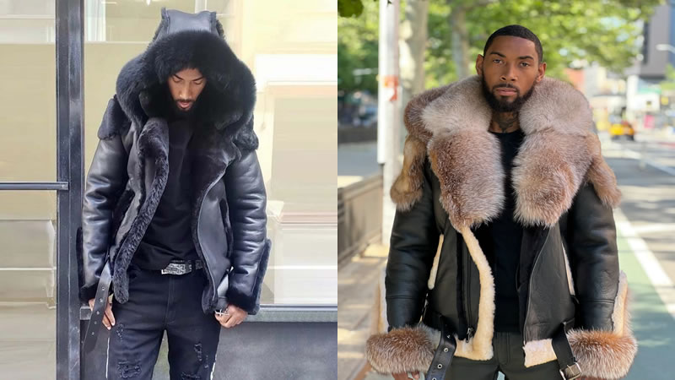

FAQs
Can fur jackets be worn in casual settings?
  - Absolutely! Many fur jackets, especially bomber styles, can be dressed up or down, depending on the occasion. Pair them with jeans and sneakers for a casual look, or dress them with trousers and boots for a more formal ensemble.
How do I care for my fur jacket?
  - It's essential to follow the manufacturer's care instructions for your specific jacket, but generally, you should avoid getting fur jackets wet and store them in a cool, dry place when not in use. Additionally, consider having your jacket professionally cleaned and stored during the offseason to maintain its quality.
Are fur jackets sustainable?
  - Sustainability varies depending on the materials and production practices used. Look for brands prioritizing ethical sourcing and production methods, such as using faux fur or partnering with certified fur farms.
Can fur jackets be tailored or altered?
  - Yes, fur jackets can often be tailored or altered to achieve the perfect fit. However, working with a professional furrier who specializes in handling fur garments is essential to ensuring that alterations are done correctly without damaging the men's fur jackets.
What is the difference between real fur and faux fur?
  - Real fur is sourced from animals such as mink, fox, or rabbit, while faux fur is made from synthetic fibers. Faux fur offers a cruelty-free alternative to real fur and is often more affordable, making it a popular choice for ethical consumers.

